Recycle Plastic Bags for Sleeping Mats for the Homeless
Plarn = Plastic Yarn
Do plarn sleeping mats make a difference? You bet.
The weather is always a challenge for those in need. One of the recipients of a plarn sleeping mat remarked how grateful he was that he would not have to look for cardboard to sleep on and try to stay warm.
Materials To Make A Sleep Mat From Plastic Bags
Plastic bags (500-700 grocery bags)
Knitting needles (size 10 or higher) or crochet needles (O or P recommended)
Scissors
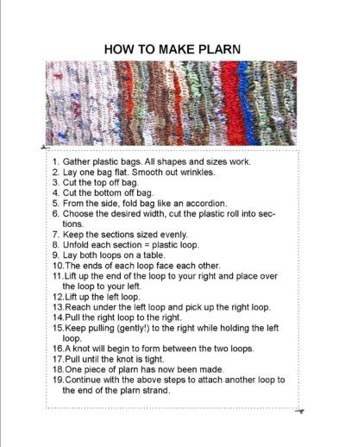

How To Make Plarn From Plastic Bags Tutorial
A short tutorial to learn how to make plastic bags into plarn. Kids absolutely can participate in the making of plarn as the scissors do not have to be sharp – only sharp enough to cut a plastic bag. This is a wonderful way for kids to learn sustainability while contributing to a volunteer project for the community.

https://thesavvyage.com/how-to-hold-plarn-drive/ This is the link on how to collect the plastic bags and a video on making the balls of plarn.
.
You are now ready to begin knitting or crocheting your plarn mat. As with any new project once you are acclimated to the plarn, the stitches will begin to fly faster after those first few rows. Anything goes with plarn – it is quite flexible and forgiving – if a piece breaks simply tie it back together with a knot and continue where you left off.

The goal is a 3′ by 6′ size plastic yarn mat. Knitters and crocheters will use their experience to test the gauge which will determine the number of plarn stitches necessary for a 3′ by 6′ mat. I used size 10.5 knitting needles with a gauge of 3.5 stitches per inch, but I am a very loose knitter.

Knit Or Crochet A Test Gauge With Plastic Yarn
Make a swatch to test your gauge to determine the number of stitches. A 3′ by 6′ marks standard size, minimum length is 5′. The thickness of the bag can slightly alter the gauge. I found thinner plastic bags such as ordinary grocery store bags (or my favorite Kroger bags!) were the easiest to knit; plarn looks thin, but actually knits or crochets like bulky yarn.
Tip: Plarn can have a tendency to be sticky on the needle, I found bamboo knitting needles were the easiest to work with plarn. Some plarners report rubbing the needles with wax paper helps the plarn glide easily over the needles. I have tired a few different types of needles from my needle stash and definitely prefer large gauge bamboo needles.
Bamboo knitting needles are inexpensive compared to steel or aluminum needles. The bamboo needles can be purchased in packs with different sizes. If you are unsure of the needle size, the bundle packs have needles up to size 15 which gives alot of latitude to find the needles which suit your gauge and the plarn. The minimum size of knitting needle used is usually 10.
Tip 2: The writing on the plastic bags may transfer to your needles; while this does not matter for the project, but just to be safe I wouldn’t use your favorite go to needles or crochet hooks on this project.
Let the knitting and crocheting begin! As with any new project once you are acclimated to the plarn, the stitches will begin to fly faster after those first few rows. Anything goes with plarn – it is quite flexible and forgiving – if a piece breaks simply tie it back together with a knot and continue where you left off.

How To Involve Children In The Volunteer Plarn Project
Holding a plarn drive is a wonderful way to involve your kids into a community service project. Of course the kids can help sort the plastic bags as they arrive; but kids can also make plarn! This is a good project to organize into an assembly line for the kids to participate.
- Sort the plastic bags by size and type.
- Straighten and flatten plastic bags.
- Cut off the tops of the plastic bags.
- Cut off the bottom of the plastic bags.
The plastic bags are now ready to be made into plarn (plastic yarn.)

The Savvy Age *** FREE Newsletter
Make life easier by receiving recipes and crafts direct to your

The Savvy Age *** FREE Newsletter
Make life easier by receiving recipes and craft

The Savvy Age *** FREE Newsletter
Make life easier by receiving recipes and crafts direct t

The Savvy Age *** FREE Newsletter
Make life easier by receiving recipes and crafts direct to your

